A
Project Based Learning
Sales forecasting for a retail store
Submitted
In Partial Fulfillment of the Requirements for the Award of Degree.
BACHELOR OF TECHNOLOGY
IN

COMPUTER SCIENCE AND ENGINEERING
(DATA SCIENCE)
Submitted By

M.Vamshi (237Z1A6770)

Mohammad.Azhar (237Z1A6771)

Mohammed.Siraj (237Z1A6772)

M.Maniroop (237Z1A6773)

N.LaxmiNarashimha Reddy( 237Z1A6780)

Under the Guidance of
Mrs. K.Nandhini
Assistant Professor

SCHOOL OF ENGINEERING
Department of Computer Science and Engineering
(DATA SCIENCE) NALLA NARASIMHA REDDY

EDUCATION SOCIETY’S GROUP OF INSTITUTION
(AN AUTONOMOUS INSTITUTION)

Approved by AICTE, New Delhi, Chowdariguda (V) Korremula ‘x’Roads, Via Narapally, Ghatkesar (Mandal)Medchal (Dist), Telangana-500088 2024-2025.



SCHOOL OF ENGINEERING
DEPARTMENT OF COMPUTER SCIENCE AND ENGINEERING
(DATA SCIENCE)

CERTIFICATE

This is to certify that the project report titled “Sales forecasting for a retail store” is being submitted by in Mohammed.Siraj Partial fulfilment for the award of Bachelor of technology in Computer Science & Engineering (DATA SCIENCE) is a record bonafide work carried out by them. The results embodied in this report have not been submitted to any other University for the award of any degree.

Internal Guide | Head of the Department
(Mrs.K.Nandhini) | (Mrs.Indrani Vasireddy)

Submission Date:

DECLARATION

I M.SIRAJ student of Bachelor of Technology in

Computer Science and Engineering(Data Science), Nalla Narasimha
Reddy Education Society’s Group Of Institutions, Hyderabad, Telangana, hereby declare that the work presented in this project work entitled SALES FORECASTING FOR A RETAIL STORE is the outcome of my bonafide work and is correct to the best of my knowledge .This work has been undertaken taking care of engineering ethics. It contains no material previously published or written by another person nor material which has been accepted for the award of any other degree or diploma of the university or other institute of higher learning.
M.Vamshi (237Z1A6770)
Mohammad.Azhar (237Z1A6771
Mohammed.Siraj (237Z1A6772)

M.Maniroop (237Z1A6773)

N.LaxmiNarashimha Reddy( 237Z1A6780)

Date:

Signature:

ACKNOWLEDGEMENT

I want to express our profound gratitude to our real-time research project coordinator, Mrs.K.Nandhini, Assistant Professor, Department of Data Science, NNRG, for her support and guidance in completing my project and for giving me this opportunity to present the research project work.
I profoundly express thanks to Mrs.Indrani Vasireddy, Associate Professor & Head, Department of Data Science , NNRG ,for her cooperation and encouragement in completing the project successfully.
I wish to express our sincere thanks to Dr.G.Janardhana Raju ,Dean School of Engineering, NNRG, for providing the facilities for the completion of the project.
I wish to express our sincere thanks to Dr.C.V.Krishna Reddy, Director, NNRG, for providing the facilities for the completion of the project.
Finally, I would like to thank Project Co-Ordinator, all the faculty members and supporting staff, Department of Data Science , NNRG,for extending their help in all circumstances.
By :

M.Vamshi (237Z1A6770)

Mohammad.Azhar (237Z1A6771)

Mohammed.Siraj (237Z1A6772)

M.Maniroop (237Z1A6773)

N.LaxmiNarashimha Reddy( 237Z1A6780)

CONTENTS PAGENO:

ABSTRACT 1

1.INTRODUCTION 2-3
1.1Problem Definition 2
1.2Objectives 3

2.SYSTEM ANALYSIS 4-6
2.1Existing System 4
2.2 Software Requirements 4
2.3 Hadware Requirements 5
2.4 Functional Reqirements 5

3.IMPLEMENTATION 7-9
3.1Methods of Implementation 7
3.2Algorithmic Approach 8

4.GITHUB 10-11
4.1 Registation 10
4.2 How to put a project into github 11

5.OUTPUT SCREENSHOTS 12-14

6.CONCLUSION AND FUTURE ENHANCEMENT 15-16
6.1Conclusion 15
6.2Future Enhancement 15
7.REFERENCES 17

ABSTRACT

Retail businesses rely heavily on accurate sales forecasting to maintain inventory levels, manage resources, and plan future business strategies. Traditional forecasting methods, such as manual calculations and spreadsheet-based prediction models, often lack accuracy and fail to capture underlying patterns in sales data. To overcome these limitations, this project presents a Month-Wise Retail Sales Prediction System using Machine Learning and interactive data visualization.
The system uses historical retail sales data from the previous year and applies a Linear Regression–based predictive model to forecast sales for the upcoming year. The dataset is preprocessed by converting dates into numerical indices to identify monthly trends and patterns. The model then learns the relationship between monthly progression and sales values, enabling it to generate reliable predictions for each month of the next year.
To provide better user experience and analysis, the project includes an interactive dashboard built with Streamlit. The dashboard allows users to view the previous year’s data, visualize trends through line and bar charts, and manually select any month to view its predicted sales value. Users can immediately observe the system’s forecast for the chosen month, enabling quick and effective decision-making. This visualization-driven approach enhances clarity and gives business managers a deeper understanding of sales trends such as seasonal variations, peak months, and performance dips.
The system is easy to use, platform-independent, and scalable for large datasets. It can be extended to incorporate multi-year forecasting, product-wise forecasting, or more advanced machine learning algorithms. Overall, this project demonstrates how combining machine learning with modern visualization tools can help retail businesses automate forecasting, reduce manual workload, improve planning accuracy, and make informed business decisions.

1.INTRODUCTION
Retail sales forecasting is one of the most important business functions that help organizations optimize their supply chain, reduce losses, and improve profitability. With increasing competition and unpredictable customer demand, accurate forecasting becomes essential.
This project introduces a Month-Wise Retail Sales Prediction System using Machine Learning. It uses historical sales data to predict upcoming year sales values. The system generates:
- Monthly trend visualizations
- Year-wise sales insights
- Interactive dashboards
- Next-year month-wise predictions
- Model-based comparison between actual and predicted values
The system is built using Python, Pandas, Plotly, Sklearn, and Streamlit, enabling real-time visualization and fast prediction updates.

  - Problem Defination
Retail businesses face challenges in predicting future sales accurately. Manual forecasting is error-prone and slow, and does not consider seasonal variations or historical patterns. This leads to:
- Overstocking or understocking.
- Loss of revenue.
- Poor inventory planning.
- Incorrect financial budgeting.
Thus, a machine learning–driven automated forecasting system is required.
1.1 OBJECTIVES
- To develop a machine learning model that predicts monthly sales for the upcoming year.
- To visualize previous year trends through interactive charts
- To allow users to manually select any month and view its predicted future value.
- To extract business insights such as best month, worst month, and demand growth.
- To enhance decision-making by providing accurate and automated forecasting.
- To build a user-friendly Streamlit dashboard for easy business
2.SYSTEM ANALYSIS
2.1 Existing System
Existing forecasting systems in retail rely mostly on:
- Manual Excel sheets
- Simple calculations (moving averages)
- Experience-based assumptions
These approaches lack accuracy, do not adapt to changing patterns, and cannot be scaled for large datasets.
2.2 Software Requriements
1.Operating System (OS):
- Windows 10 / 11 (Recommended)
- macOS or Linux (Optional, supported by Python)
2. Programming Languages:
- Python: For controlling hardware components, sensors, and logic.
- JavaScript / Node.js: For building interactive modules and front-end display.
- HTML/CSS: For designing the user interface on the mirror display.
3. Frameworks / Platforms:
StreamlitUsed to build an interactive dashboard for
- Month selection
- Displaying predictions
- Visualizing charts,Showing data tables.
4. Database:
- SQLite or Firebase for storing user preferences, profiles, and historical data.
2.3 Hardware Requirements:
- Minimum 4GB RAM
- Any modern CPU (i3/i5)
- Internet (for running Streamlit cloud/optional)
- 500MB disk space

2.4Functional Requirements:
- Upload or load sample dataset
- Display previous year data
- Train ML model
- Predict next-year month-wise sales
- User can choose any month
- Show predicted output for that month
- Display trend graphs

Non-Functional Requirements:
1. Performance
- System should load data and generate predictions quickly.
- Dashboard should respond without delay.

2. Reliability
- System should run smoothly without crashing.
- Must give consistent results for the same input.
3. Usability
- Interface should be simple and user-friendly.
- Charts and results must be easy to understand.
4. Scalability
- Should support large datasets (up to 200 MB).
- Easy to add more features in the future.
5. Maintainability
- Code should be easy to modify and update.
- Proper comments and structure for future improvements.
6. Security
- Should accept only safe CSV files.
- No user data should be stored permanently.
7. Portability
- Should run on Windows, Linux, and macOS.
- Works on all modern web browsers.

3.IMPLEMENTATION:
3.1 Method of Implementation
The system follows:
- Load dataset (2024 data)
- Convert Date → Month → MonthIndex
- Train Linear Regression on MonthIndex vs Sales
- Predict next-year (2025) sales
- Create a dashboard
- Display charts and insights

3.1.1 Technologies Used
1. Python
Main programming language used for data processing, machine learning, and backend logic.
2. Streamlit
Used to create an interactive dashboard for sales prediction and visualization.
3. Pandas
Library for loading, cleaning, and manipulating dataset (CSV files).
4. NumPy
Used for numerical operations and converting months into numeric indexes.
5. Scikit-Learn
Machine learning library used to build the Linear Regression prediction model.
6. Plotly
Used for interactive graphs such as line charts and bar charts to visualize sales trends.
7. Visual Studio Code / Jupyter Notebook
Programming environment used for writing and testing code.

3.2 Algorithmic Approach
Linear Regression
Linear Regression is a machine learning algorithm that shows how one variable affects another.
It draws a straight line through data points to predict values.
- Import dataset
- Convert dates into numerical indices
- Fit regression model
- Predict future indices
- Map predictions to months
- Display forecasted values

4.GITHUB INTEGRATION
GitHub integration allows developers to manage, version, and collaborate on the Smart Mirror project’s software efficiently. It ensures code backup, version control, collaboration with multiple contributors, and smooth deployment of updates.
4.1 Registration:
.Visit https://github.com and sign up using your email.
.Once the account is created,install Git from https://git-scm.com.
.After installation,configure Git on your local system using the following terminal commands:
git config-global user.name “your Name”
git config-global user.emailYour.email@example.com

4.2 How To Put A Project Into Github:
Once your project is developed locally,follow these steps to push it to remote GitHub repository:
Intilize Git inside your project folder:
git init
Add all files to the staging area:
git add
Commit the added files:
git commit -m :”Intial commit”
Create a new repository on GitHub.
Example:https://github.com/yourusername/portfolio-site
Link your lolcal repository to GitHub:
git remote add origin: https://github.com/MohammedSiraj-7/sales-forcecasting-.git
git branch -M mains
git push -u origin main
All changes made locally can be synced to GitHub using just:
git add
Git commit -m “message”
git push

5.OUTPUT SCREENSHOTS
FIG:1
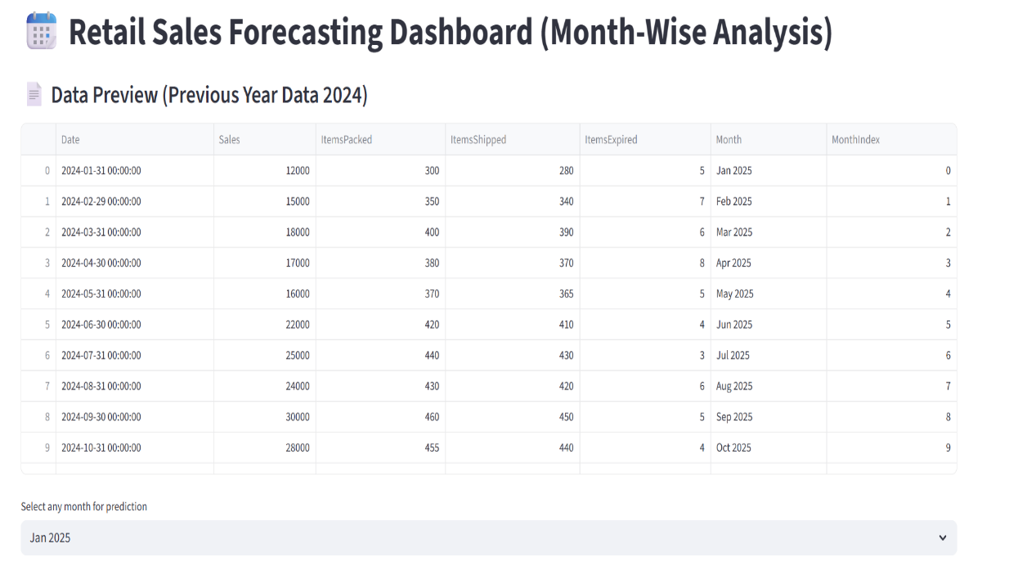

FIG:2
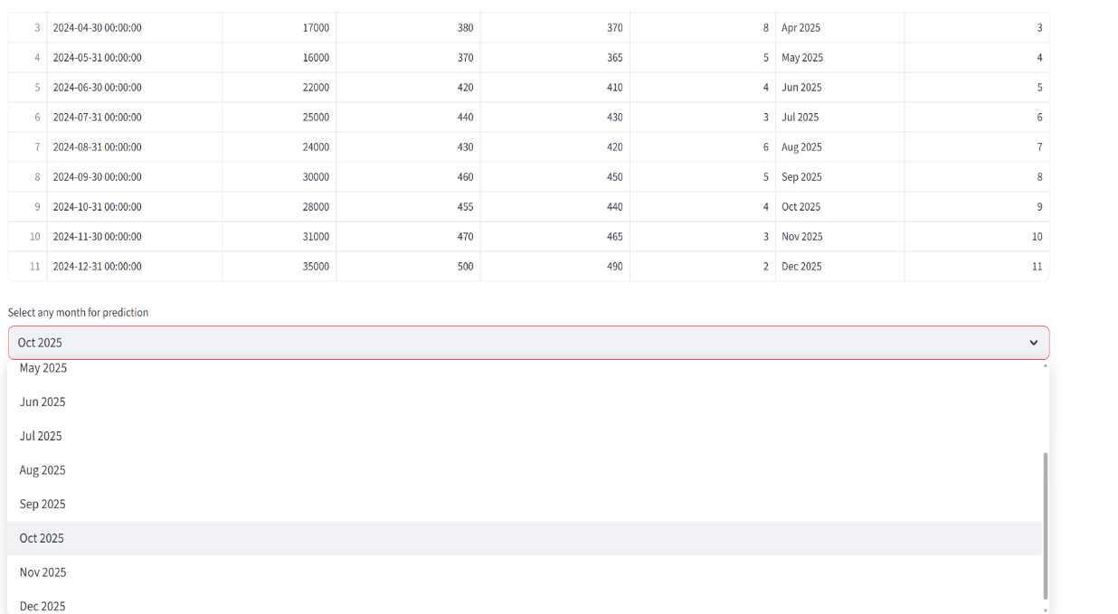

FIG:3
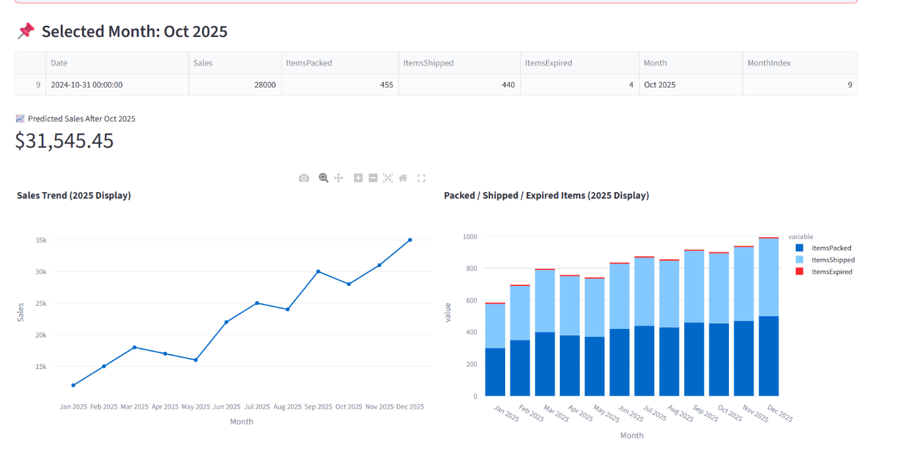
FIG:4
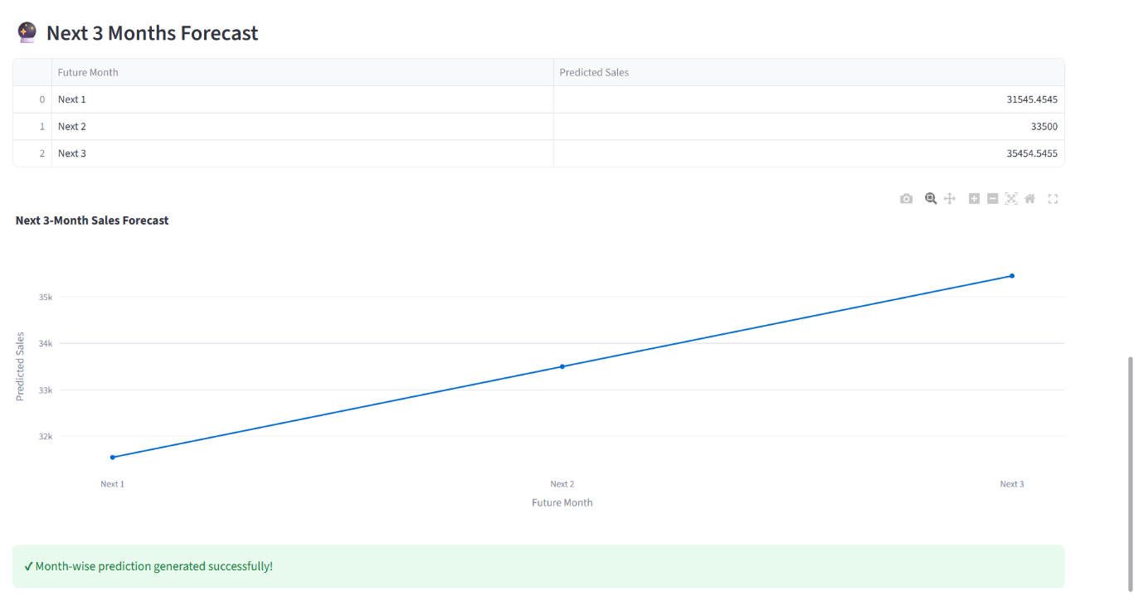

6.CONCLUSION AND FUTURE ENHANCEMENT
6.1 Conclusion:
The project accurately predicts month-wise retail sales using machine learning. The interactive dashboard makes it easy for retail managers to visualize trends and plan operations. This ML model enhances decision-making by reducing forecasting errors and improving business intelligence.
6.2 Future Enhancement
- Deep Learning / LSTM-based predictions
- Automated CSV imports via cloud
- Multi-year forecasting
- Integration with ERP systems
- AI-based anomaly detection

7.REFERENCES:

- Scikit-Learn Documentation
MachineLearninginPython
https://scikit-learn.org/
- StreamlitDocumentation
Frameworkforbuildingdataapps
https://docs.streamlit.io/
- PandasDocumentation
PythonDataAnalysisLibrary
https://pandas.pydata.org/
- NumPyDocumentation
ScientificcomputingwithPython
https://numpy.org/
- PlotlyDocumentation
InteractivevisualizationsforPython
https://plotly.com/python/
- Jason Brownlee (2019). Machine Learning Mastery with Python.
Machine Learning Algorithms and Techniques.
- O’Reilly Media – Python for Data Analysis (Wes McKinney)
Data cleaning and analysis using Pandas.
- Research Papers on Sales Forecasting:
- C. Chatfield (2000), Time-Series Forecasting.
- S. Makridakis et al. (1998), Forecasting Methods and Applications.
- KaggleDatasets&MLExamples
https://kaggle.com/
- YourProjectDataSource
(Retail store dataset manually prepared for month-wise sales forecasting.)

